**Phase 3**

*Process Control Diagram –*

*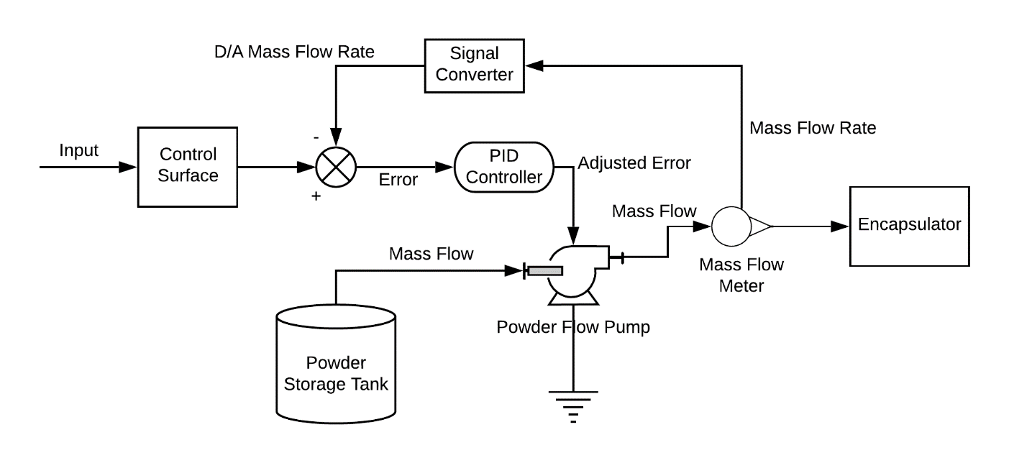0*

The main controlled variable in this system is the powder flow pump. This vacuum conveyor manifold will transport mixed formulation from the storage tank to the encapsulator unit operation. The pump must operate at a very specific flow rate to ensure that the encapsulator has enough formulation to operate at the desired output rate. Too much powder, we could overflow the machine and lose product, not enough, and the line will stall, and product output will decrease.

We utilize a proportional, integral, and derivative control mechanism to control this system. Below is a list of **uncontrolled, manipulated, and output variables**.

Variables:

|  |  |  |
| --- | --- | --- |
| **Uncontrolled** | **Manipulated** | **Output** |
| Voltage to Pump | Error | Mass Flow Rate |
|  | Input | Capsule Fill Rate |
|  |  |  |
|  |  |  |

*Optimization –*

The main concern for optimization of the encapsulation process is the cost to power the vacuum conveyor pumps that push around our product. In industry, the angle of repose is a metric that can characterize the powder flowability of product. A smaller angle corresponds to a higher degree of flowability. Glidants are often added to formulations to help bring down this angle of repose and subsequently increase the flowability. Glidants are expensive, however, and there is a trade off between the amount that can be added and the product cost of our material. We wanted to optimize the mass fraction of glidant in our formulation. To do so, we had to be able to estimate the angle of repose of our product, and we had to calculate the hourly product cost while comparing that to the hourly pumping cost.

$$Cost of Pumping = αθ^{2}$$

$$Cost of Material = \dot{m}\left(x_{g}C_{g} + x_{d}C_{d} + x_{f}C_{f}\right)$$

While the equation for the angle of repose is a Choi-Okos type equation. Calculating the total cost of materials and pumping for various mass fractions of glidant xg, we obtain the following graph:

One can see quickly that a minimum is reached at just about 37% magnesium stearate. This puts our dextrose weight percent at 31.5% and our fiber weight percent at 31.5%. From there, we can then go on to calculate the hourly, monthly, and yearly production costs due to the powder flow and the actual raw material costs.